Make a Paper Castle
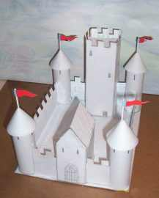
This is a complete project that shows you how to make a medieval castle out of paper and cardboard. I give you all the templates and instructions. The project takes about 2-4 hours to complete depending on your skill level. And you have a lot of flexibility in how you decorate it. Lots of people have made this castle and sent me pictures. There are some wonderful results. You can see their castles here: Pictures of this castle that have been submitted to this website.

Here is the paper and cardboard castle that you build in this project.

The picture you see here is the castle in an unpainted form and ready for you to paint.

There are some unique things about this project and this castle. The whole thing fits on an 81/2 x 11 sheet of paper which makes it a manageable project and not too time consuming.

I give you all the components on paper so you can print them out and cut them out. All you need is a few basic supplies and tools.
A Learning tool: I have included a fact and information sheet about this castle and it points out the major structures and how they work. It's a good tool for learning about the why and how of castles. This model castle follows these learning points perfectly. So a child can learn about castles while it is being built. (To make this castle just scroll down a bit. The tutorial and step by step instructions begin below.
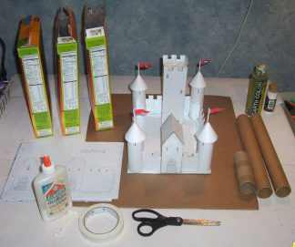
Parts and Tools Needed for this Project
3 Empty Cereal Boxes
White Glue or paste
4 Bathroom Tissue tubes or 2 Paper towel tubes - if you use paper towel tubes cut them to 4 and a
Half inches in height so you have four of them (1 for each tower)
Scissors
Masking Tape (optional)
7 Page printout of the castle design and parts (included here)
Some General tips about making the castle before you begin:
About Glue: You should always use the glue very sparingly. If you use a real lot it will distort the paper and the cardboard a bit and make it look a bit wrinkled.
About the Cardboard cereal boxes: You can make this whole project without using any cardboard. You can just cut out, fold, and glue all the different paper parts together but this is very challenging! It takes a deft hand and very minimal glue. Best results are if you use cardboard. It will add stability to your castle.
Let’s Make this Paper Castle!
Here is the learning sheet about castles that goes along with this project learning about Castles (Microsoft Word doc).If you can't get the word document I also have it here on a webpage for you to print out here. I also have this complete package in a puff which is easy to download and print PDF of the Paper Castle Project
Here is the 8 page document you can print out that gives you all the parts of the castle Castle Parts (Microsoft Word doc) If you have trouble with the Word document here are the eight pages in a jpg picture form so you can print them:
Castle footprint (Base of the Castle)
Castle Keep (Big tower in the back)
Castle Walls
Castle Gatehouse
Keep Roof, Flags, 1 more wall
Tower Turrets (cone shaped)
Tower Walls
Tower Walls 2

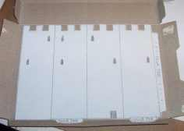
Step 1: Printout and cut out all the various shapes from the booklet of parts. Glue these parts down onto the cereal box cardboard. Once the glue has dried you can then cut out the cardboard shapes. Leave the paper on! You may want to glue the paper to the coloured side of the cardboard. It will hide the colour and will make painting the castle easier. I show here that I glued to the plain inside of the boxes.

Glue Tip

When gluing the castle parts to the cardboard use a liberal amount of glue all over the cardboard but keep it thin (not big globs or lines) and use a cotton swab stick to spread it around.
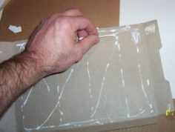

Build the Turrets
Glue the tower walls to your four tower tubes. They should be four and a half inches tall. Cut out circle tower tops and fold them into cone shapes. Use a very small amount of glue to do this. Finally, apply glue to the top of the towers and glue the tower cones on top! After you put the cone on top hold your finger on it for a minute to allow the glue to dry. Or put a couple of small pieces of tape to hold it on top while it dries.
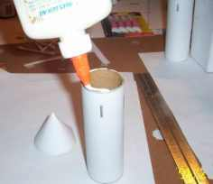

Bending Tip: When bending the various sharp edges of your castle use a rule or a piece of wood. It will help you keep all the edges straight and sharp.

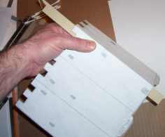

Tower and gatehouse
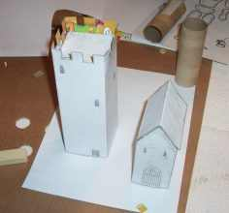
Now cut out the tower keep, tower keep roof, and the gatehouse. Fold them up and glue them. Glue the roof of the keep into the tower keep. I folded the keep but didn't glue it closed, I then glued three edges of the roof into place and finally glued the tower closed.

Now you are ready to glue all your parts to the base of the castle. You should have a keep tower (biggest) a gatehouse, 4 round towers, and 6 tower wall sections.
Glue sequence
For the best looking results you should glue the parts to the base in a linear sequence something like I have shown here. Glue the tower labelled 1 down first. Then glue the wall section (2) to it. Then glue the gatehouse, and then section 4. Continue all the way around until you are done. Doing it in sequence like this will give you the best results in look.
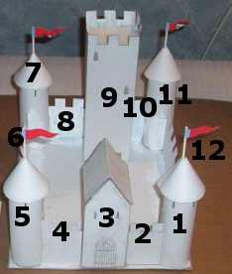

Finally, Cut the tips off the tower tops and glue a toothpick or trimmed cotton swap stick into it. These are the flag poles. Finally glue your flags onto the poles. (Paint or colour the flags first!)

Where do we go from Here? Have some fun painting and decorating your paper medieval castle. You can also glue lots of things to it like string, yard, glitter or even macaroni!
More Castle Projects Coming: I am currently beginning work on two more cardboard castle projects. The second one is table top sized but larger, more complex and based on a real castle. And the third one is a very large floor model that will be between six and eight feet in size so you can climb right into it! Check back again to this page or the home page here. Have Fun with your castle and share it with your friends!
Want to learn how to draw a castle? Here is a nice website with complete instructions:
DrawingStep.com - Lots of interesting and creative drawing lessons including a lesson on how to draw a castle here. Search Fantasy Cartoon Castle Drawing.

